1. *Go to the library and look through some of M. C, Escher’s work*
2. *Look at 5 curves from this* [*list*](http://v) *of famous curves. Record what you find interesting*

Create a presentation looking at different hanging curves (parabola, cable wire,

Idea:

1. Fundamental Theorem of Arithemetic - Sieve of Aristophanes slab, small wooden slab with circles students can color in to learn about the atoms of numbers

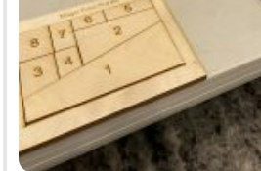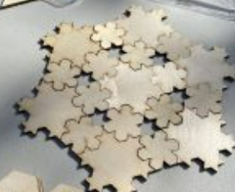

Activity Ideas

1. *Partition a shape and try to have kids recreate it*
2. *Explore patterns that emerge from wonky shapes (tessellation-building)*
3. *Create a new fractals (like Koch)*
4. *Look for a cool pattern with lots of shapes (Circle of Life)*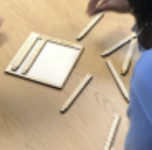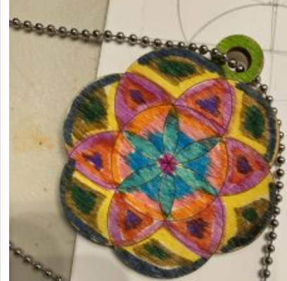
5. *Create a visual representation of math puzzle (like Napiers bone’s and towers of Hanoi)*

*Specials*

* Create a **flip book** to illustrate math concept (such as moving voronio diagrams)
* Calipers for measuring **proportions**

Public Math

Hexagon Challenge

* You split up a hexagon into different regular pieces and have participants try to reconstruct the original polygon (made out of paper / cardboard)

Number Cheez Its - Use laser to etch numbers and operations into cheese its

Minnesota Man - Christopher

Set up his own shop and website to distribute math toys, helping parents encourage their child’s math development.

Best experience = Recognizing a pattern (tilting)

1. Divided up familiar pattern into smaller ones (shapes) and put the back together
2. Make unfamiliar small shapes and have surprising patterns appear when playing with them

In order to understand mathematics, experience with both symbols and visuals are needed. A passion for math is supported by both